**Air University**



**Department of Computer Science**

**Subject: ICT**

**Semester Project:**

**Building a website**

**Website Name:**

**AdventuresInPakistan**

**Group Members:**

**Shanza Ashraf (232489)**

**Rabbia Jamil (232399)**

**Topic of Website:**

**Tours and information of northern areas of Pakistan**

**Task 1:**

**Purpose of Tourism website:**

The purpose of this website is to promote and facilitate travel to a particular destination or region. Tourism websites serve as digital platforms that provide information, inspiration, and practical resources for individuals attracted in visiting a specific location. tourism website aims to attract, inform, and assist potential travelers in exploring and experiencing a destination. It plays a crucial role in promoting tourism, supporting local economies, and promotion a positive travel environment.

The purpose of a tourism website for the northern areas of Pakistan is to effectively market the region, provide valuable information to tourists, promote sustainable practices, engage with local communities, and contribute to the overall growth of tourism in the area.

People all over the world are fond of travel and tourism. People often find it difficult to search for the best places. To address the issue, we adopt the travelling website which will offer best places among others

This website contains highlights of some important places along with high quality photography and allow people to book their dream destination with in their budgets. It also includes full customer support, book as per your time choice, full virtual tour of place through different videos and images.

This project is based on how an effective travel website will make us feel. It is based on a travelling website with fully featured functions that will activate the travelling bug with exciting imagery.

The website aims to promote and showcase the beauty, uniqueness, and attractions of the northern areas to attract tourists. It serves as a promotional tool for the region as a whole.

**Portfolio for tourist:**

The primary purpose of portfolio is to provide to tourists visiting the northern areas of Pakistan. The portfolio serves as a comprehensive online guide and resource hub for individuals planning to explore the beauty, culture, and adventure that the northern regions have to offer.

With a focus on user-friendly design and comprehensive information, the portfolio aims to engage tourists effectively and convert their interest into actual visits. It provides the necessary details for trip planning, encouraging tourists to explore the northern areas.

The primary purpose is to serve as a comprehensive information hub for tourists interested in exploring the northern areas. This includes details on attractions, accommodations, activities, local culture, and travel tips.

The portfolio actively promotes the northern areas of Pakistan as a must-visit destination, contributing to the broader efforts of showcasing the region's unique offerings and development positive tourism experiences.

Supporting the local tourism industry by providing exposure to businesses such as hotels, tour operators, restaurants, and other services. This, in turn, contributes to the economic growth of the region.

The purpose of my tourism portfolio is not only to serve tourists but also to strategically position the business for growth, collaboration, and success in the competitive tourism industry.

**Target Audience:**

The target audience of tourism website is tourists, primary goal is to provide to individuals who are seeking information and assistance in planning their trips. Those who might be exploring options for their next vacation and seeking inspiration or detailed information about a specific location. Individuals who have a general interest in travel and search, even if they haven't finalized their travel plans. They visit the website for inspiration, travel tips, and to discover new destinations. Travelers who are specifically interested in adventure tourism, seeking information on trekking, mountaineering, water sports, or other adventurous activities in the destination. Tourists with an interest in cultural experiences, historical sites, local traditions, and events. They visit website to gain insights into the cultural richness of the destination. Individuals who have a general interest in travel and exploration, even if they haven't finalized their travel plans. They visit the website for inspiration, travel tips, and to discover new destinations.

**Task 2:**

Sketch Your Website Layout on Figma

* Create wireframes and prototypes for your website.
* Design the layout, color scheme, and overall aesthetic of your website.
* Include sections such as Home, About Me, Projects, Skills, and Contact.

**Simple Website design without pictures and aesthetic on Figma:**

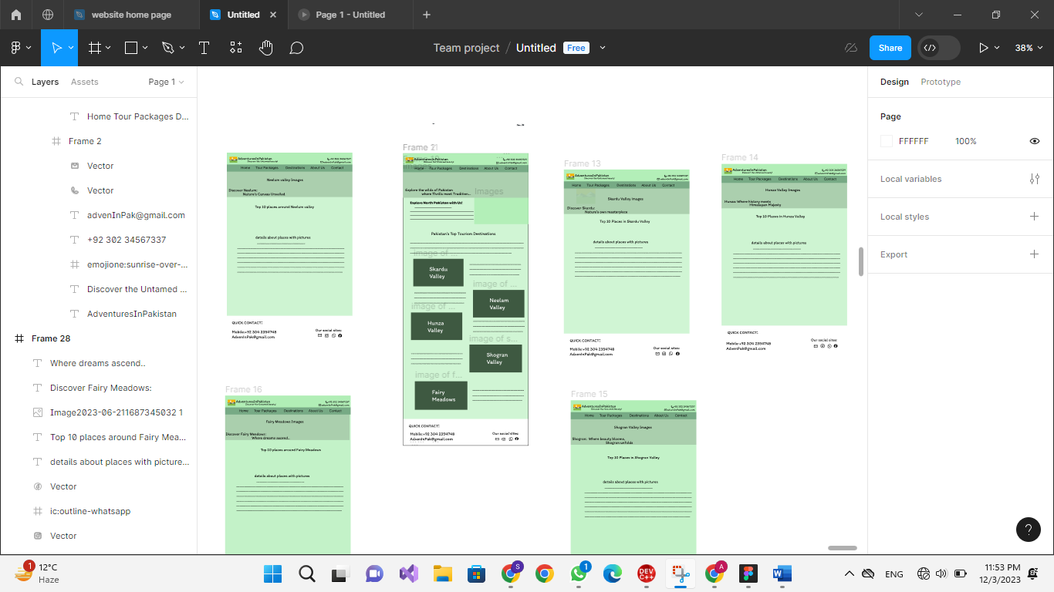

**Website Design with color scheme, layout and pictures:**

